Driffield & Rural Ward and
East Wolds & Coastal Ward Update for December 2019

- CRIME AND ASB

Driffield and Rural Ward –

East Wolds and Coastal Ward –

TFMV - Theft from motor vehicle TOMV - Theft of motor vehicle ASB - Anti-social behaviour

Driffield and rural ward has seen significant increase in offences when compared with the previous year. Many factors could be attributed to this including increased methods available to report crime and increased confidence in reporting to the police. Opportunist criminals are always on the look-out for easy targets. There are numerous affordable security devices available on the high street which will make your property less desirable to thieves. Please call in to the police station or contact one of your neighbourhood officers for further crime prevention advice.
PS 505 Kirkwood - Neighbourhood Policing Sergeant

- Crime Issues of particular note

During December damage was caused to the paintwork on a vehicle whilst parked in Washington Street, Driffield and a mobile phone was stolen from another vehicle that had been left insecure and unattended on Westgate.

Cash was taken from a residential property on Wansford Road where entry was gained through an insecure door.

An electronic computer guidance system was stolen from a tractor in the Kilham area and a van was damaged on East Street, Kilham.

The two occupants of a black vehicle attempted to gain entry to the Costcutter supermarket in Brandsburton by repeatedly kicking the door. They failed and left the scene.

Thieves gained entry to a timber yard in Catfoss however nothing was stolen.

At the end of the month there was a report of a residential Burglary in Carnaby where a vehicle was stolen from the driveway of the address. It was located later the same day after being abandoned in the Orchard Park area of Hull.

If you have any information on any of the above crimes please call us on 101

- What’s Happening In Your Area?

Residential & Commercial Burglaries
Residential and commercial premises have been targeted in Driffield and surrounding villages. Resources are being directed to vulnerable areas however we would ask householders and businesses to review their security arrangements and upgrade them as required. Also we would like the public to be vigilant and report, at the time, any suspicious incidents.

Rural Crime
Officers will continue to conduct drop-ins to farms and businesses to offer advice on target hardening their assets. Fly tipping remains a focus with officers working alongside the East Riding Council Environmental teams to apprehend the culprits.

Thefts of Lead from Church Roofs
A number of churches have been targeted with the lead being stolen from the roofs. This has continued, We will be patrolling vulnerable areas however ask for people living near churches, especially the more rural ones, to ring 101 should they notice anything suspicious or out of the ordinary. If they feel a theft is in progress please consider calling 999.

Operation Galileo
Officers from across the East Riding of Yorkshire area continue to engage in the prevention and detection of wildlife offences and poaching across the ward area. Officers will be using intelligence, new equipment and volunteers in helping to identify offenders and obtaining evidence to form prosecution cases. If you see people with dogs in fields, and if safe to do so, please ring 101 and report the incident.

Operation Galaxy

Our Op Galaxy officers are focused on proactively tackling crime and those responsible for it. Our task force is also able to identify vulnerabilities and help vulnerable people while we are out in our communities. Please take a look at the news section on our website for frequent full updates and details of arrests made.

- Crime Reduction / Safety Advice

Please consider some of the below advice aimed at reducing your risk of becoming a victim of vehicle crime.
• If you have a car alarm, activate it
• If you have access to a drive then it may be a good idea to park your car there rather than on a road side with pedestrians passing regularly
• Remove valuable items from show. For example satellite navigation systems, bags etc. This shows a potential criminal what their reward would be.

If you own a work van/vehicle have extra locks fixed and remove tools overnight. Display stickers stating that you do not leave tools in the vehicle. This shows potential criminals that you are security savvy and that the risk may not be worth the reward.

- Meet your officers -

HumberTalking continues within the East Riding area. Teams of neighbourhood officers, PCSO’s and volunteers are knocking on doors and asking residents to answer a few short questions. Your responses will be used to help us set priorities and understand what matter to you in your community. We are currently door knocking in Hornsea with Driffield being the next area to be visited.

Our Officers attend Police surgery meetings in your area on a regular basis and will be pleased to meet you to discuss any issues. To find meetings in your area please visit our website at www.humberside.police.uk. On the home page click on ‘About Us’ then ‘Find your community policing team’. Click on your area within the map and then press the ‘Go To Team Page’ button. At the bottom of the page you will see a list of meetings.

- News and Appeals

My Community Alert updates

- Good News Vehicle Seized - Alert message sent 30/12/2019 07:42:00
Sunday 29/12/2019. Vehicle seen in Suspicious Circumstances in the Bridlington Driffield Area, made off from Police when approached , vehicle swiftly located by Driffield Community Officers and vehicle seized for Fail to Stop No Insurance.
Message sent by Chris Webster (Police,PCSO,Driffield Comunities)
- Suspicious Vehicle Kilham - Alert message sent 29/12/2019 07:10:00
suspicious vehicle seen in kilham at 2130 hours 28/12/2019 green vw golf, the vehicle was driving slowly around the village, with a female from the vehicle seen to look round residents gardens, if seen call 101 log 521 28/12/2019 refers
Message sent by Chris Webster (Police,PCSO,Driffield Comunities)

- Suspicious Male Thwing Area - Alert message sent 28/12/2019 11:22:00
Reports of a suspicious male in the Thwing area on Christmas Day offering Lobster and Crab for sale, stating he had caught them that morning , male had a good knowledge of the local area, male described as a white male, 25 years old, wearing a scruffy blue jumper and blue jeans. Log 164 26/12/2019 Refers.
Message sent by Chris Webster (Police,PCSO,Driffield Comunities)

Please visit our website www.humberside.police.uk for the latest news & appeals, and find out more about My Community Alert.

- Useful information

Importance of Reporting incidents/crimes
Just a reminder that it is really important you report any crimes or suspicious incidents to us. This can be either via 999 or the 101 phone number, via our web site, or personally at a police station or to an officer in the street. Only by reporting the crime/incident can we be aware of it. Once we are aware we may not be able to do anything about it immediately but the report will form part of a wider picture which helps inform where we direct officers to patrol and focus activity. So please ….. take the time to report a crime/incident in the knowledge your time is not wasted. www.humberside.police.uk

The Neighbourhood Policing Team meet regularly with partners to ensure we have a multi- agency approach to local issues, individuals and problem solving. These meetings are regularly attended by partners including Humberside Fire and Rescue Service, Youth and Family Support, Housing Officers, Environmental Health and the East Riding Anti-Social Behaviour Team. We share information and resources to deal with local neighbourhood issues, in particular, those identified as causing the most harm in the community.

National Crime Statistics - Please look at this link to https://www.police.uk
Click on ‘Find Your Neighbourhood’ and input a post code. You can interrogate the data and get some quite specific crime information. Please be aware that the data can be a month or 2 behind.

Also follow us on www.twitter.com/@Humberbeat_ERYN



AREA COVERED BY DRIFFIELD & RURALTEAM

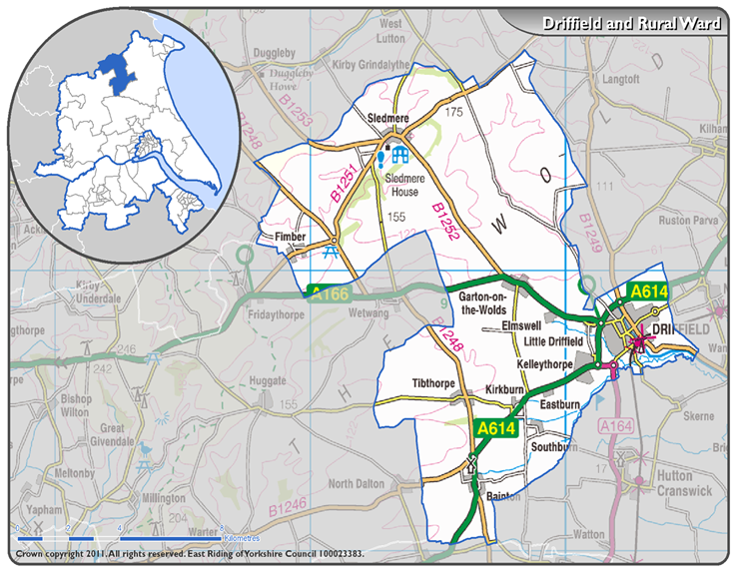

AREA COVERED BY EAST WOLDS & COASTAL TEAM

